Hardware Implementation of IoT-Based Health Monitoring System:
STM32 Development Board :
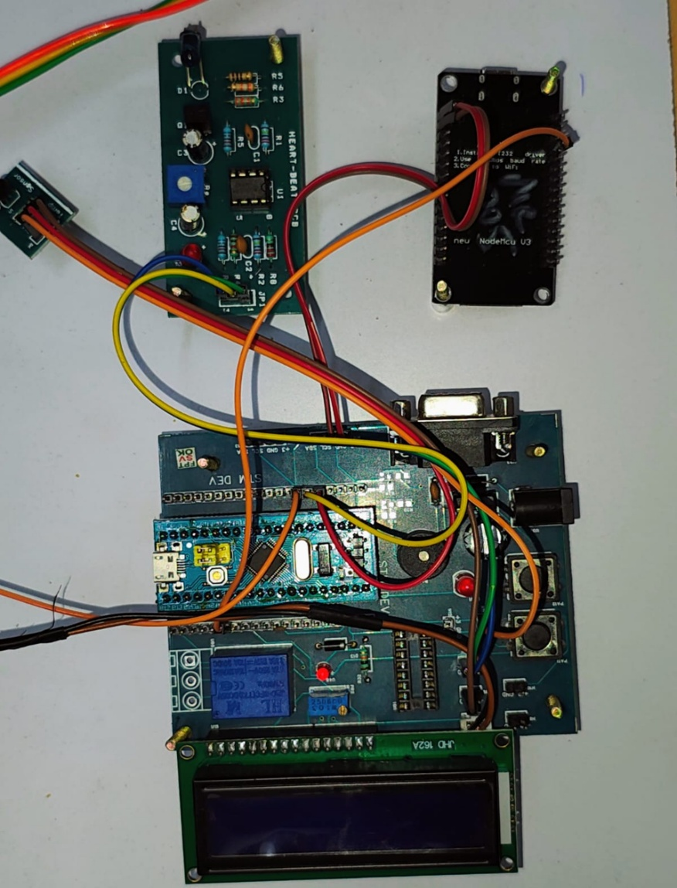
STM32 Wiring Connections (Pin Configuration)
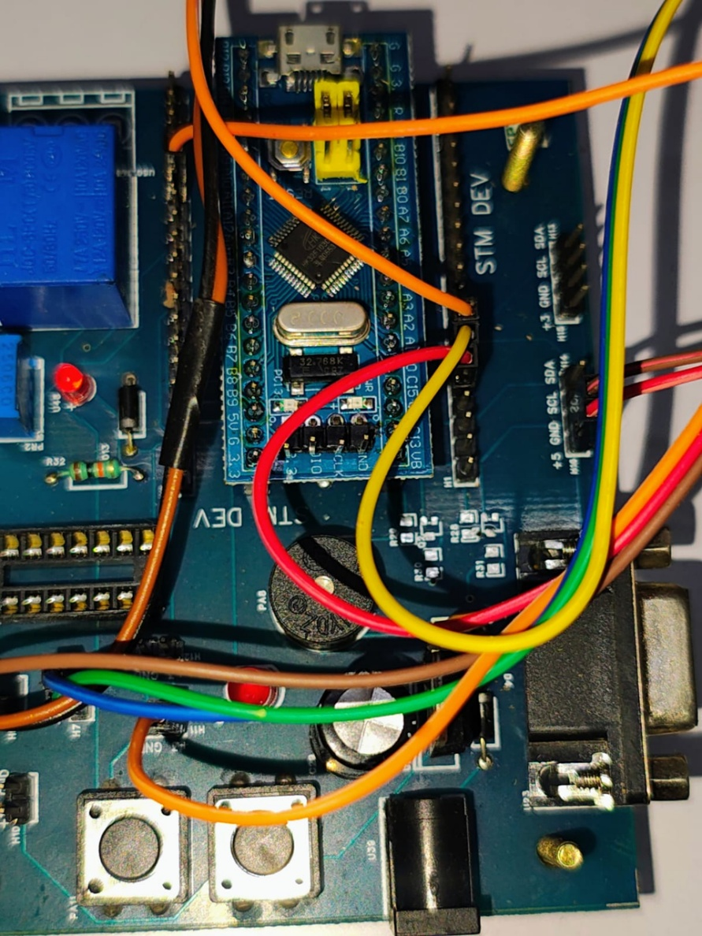
Heart Rate Sensor Development Board
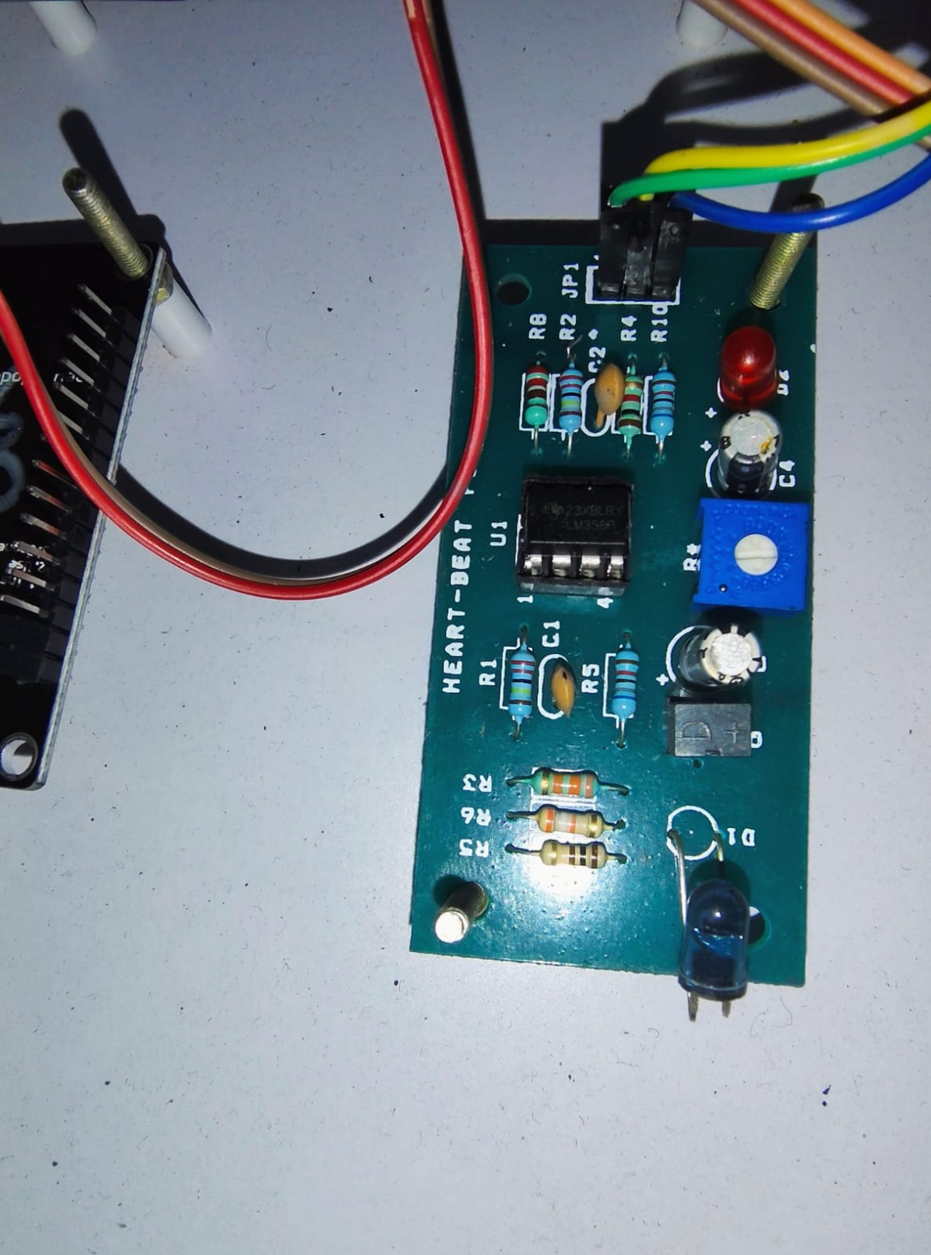
16x2 LCD Display with Relay Interface Setup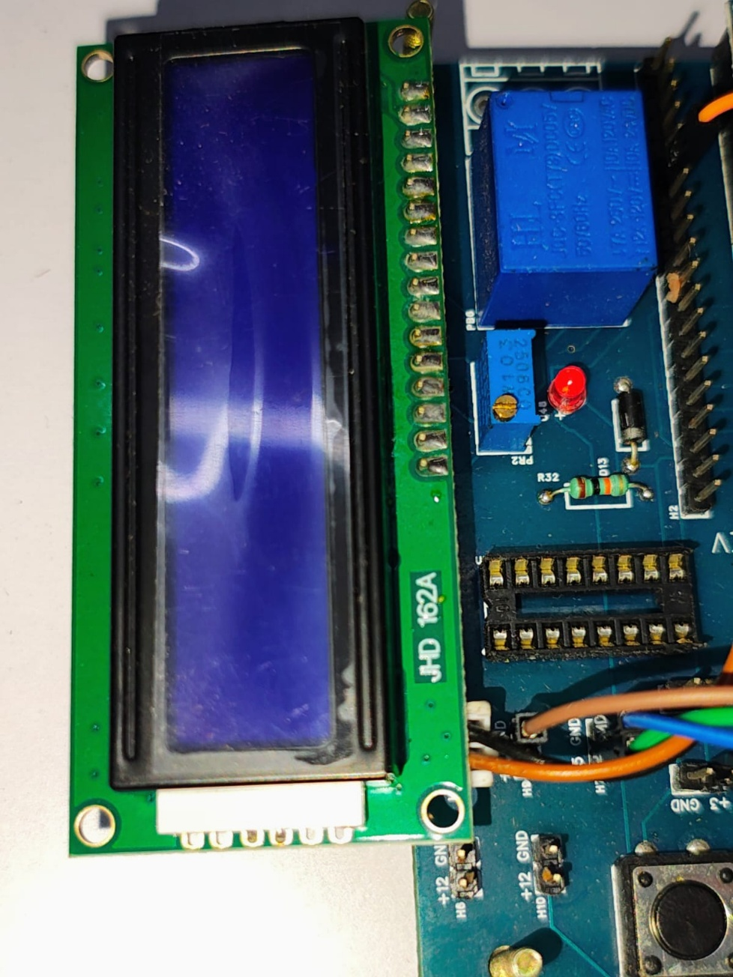
Hardware Setup of Health Monitoring System (Sensor and Controller Integration)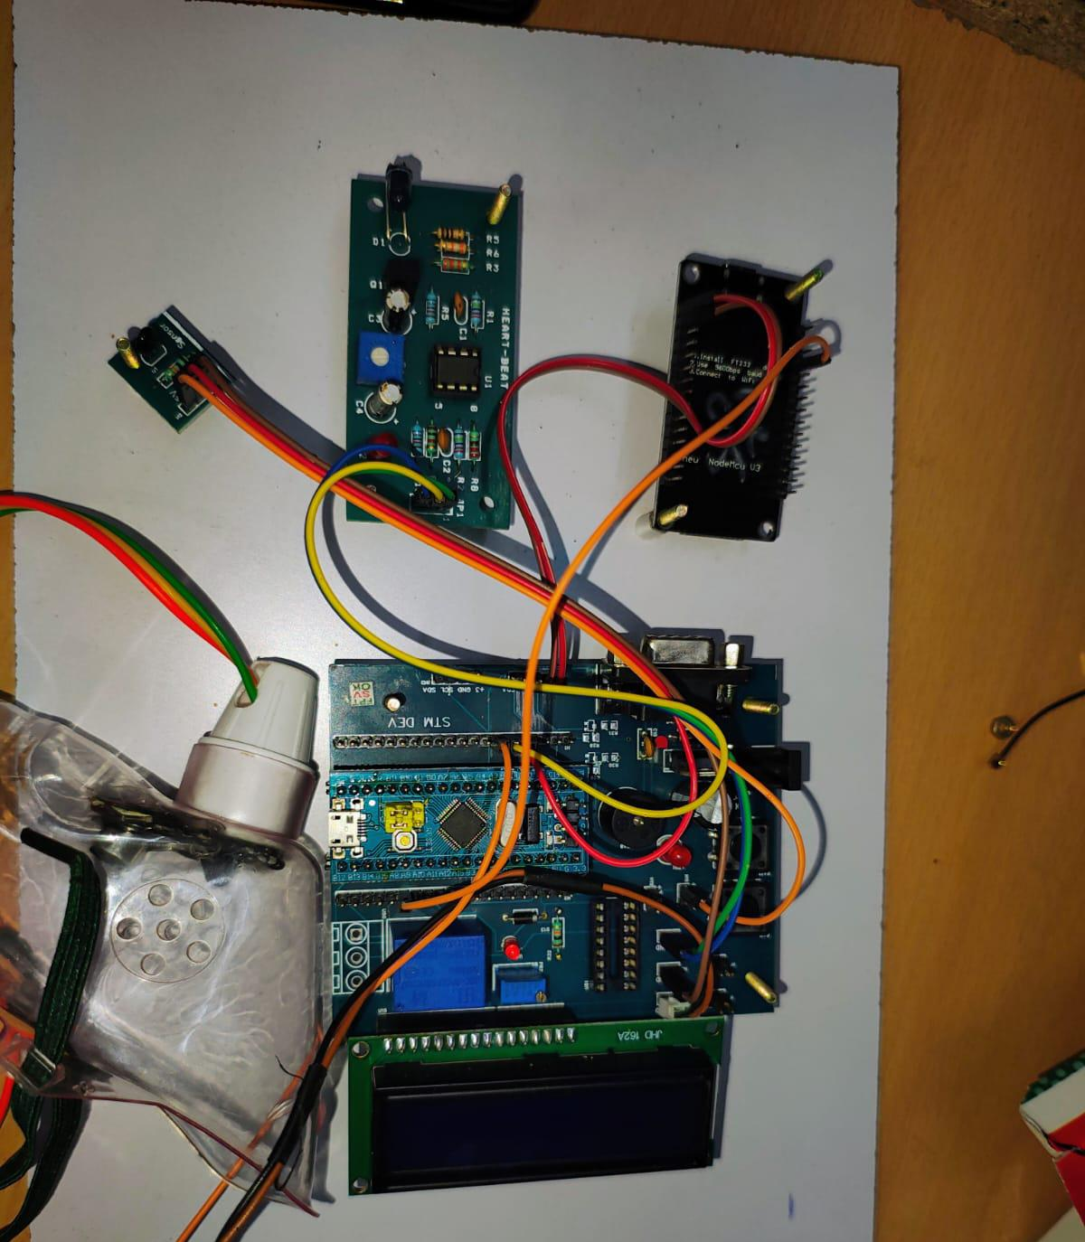
Prototype Smart Mask with Embedded Sensor Integration
